Greetings and Merry Christmas from Peru!

We had a restful break during Thanksgiving week and we are continuing to reflect upon how we have so much to be thankful for! Most incredible is the undeserved grace and mercy of the Lord and His gift of salvation! We are especially thankful for each of you that join with us in this ministry and who enable us to be on the field through your prayers and support!

October marked 19 years since we moved to Peru and it is encouraging to see the sanctifying fruit of God as He continues to work and call Quechua believers to participate in His plan for these isolated people. To have so many dear friends who have faithfully supported us all these years is so encouraging! We are extremely grateful, and we are once again reminded of the blessing of a diverse team that the Lord has put together to help reach the La Union Quechua people for Christ!

Because of Him, we are all working together to magnify and glorify our Lord Jesus through bringing truth and love to the Quechua people.

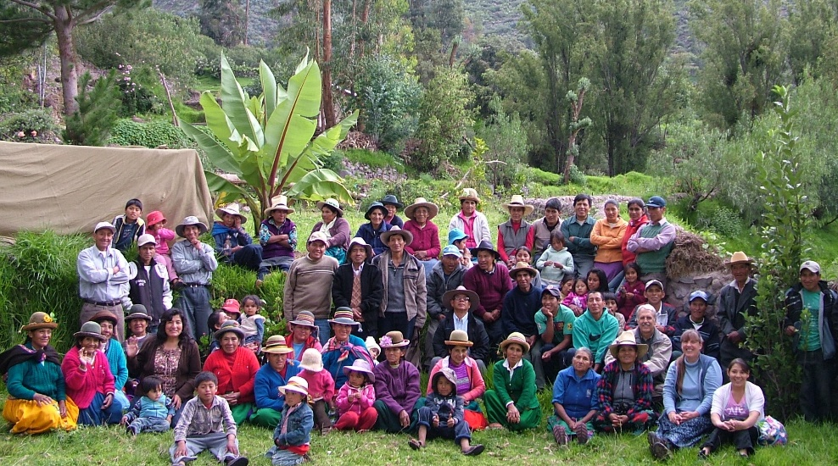
One of our many Bible Training Seminars over the years

November 9th & 10 was the weekend Bible training seminar. It is always a good time for believers to gather together for concentrated times to focus on their spiritual growth and encouragement through times of fellowship. Seventeen years ago, we held the first Bible training seminar, and have continued every 2 months with topical teaching according to needs and challenges.

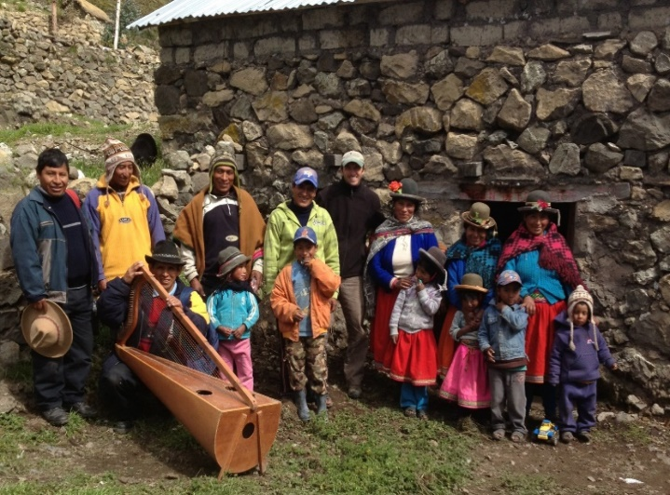

A small church in the village of Chincayapa
(pronounced like: cheen-c-eye-yapa)

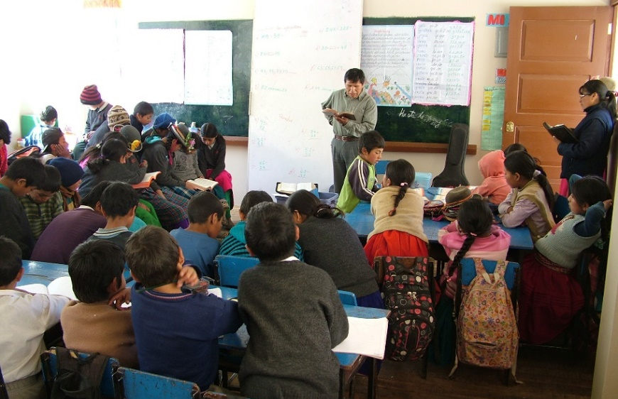

Most public-school teachers are open to the gospel and interested in our ministry. During our monthly visits to the more remote villages they invite us to teach Bible in the local Quechua dialect. What an opportunity for all!
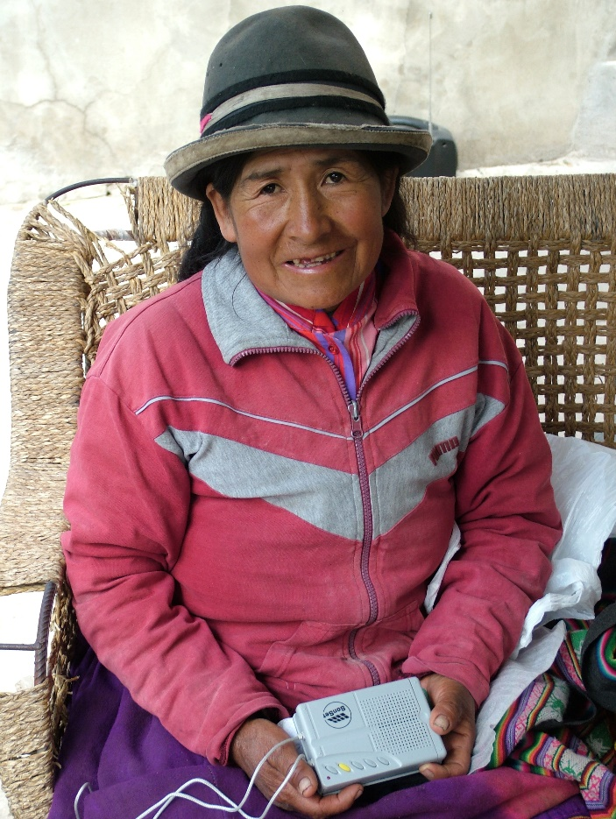

Many listeners of our radio programs are giving thanks for the Lord’s help in getting back on the air. Even though it is provisional, the current solution enables us to work toward repairing the damaged equipment while continuing ministry. This believer happily received a solar radio receiver so that she can listen to the Christian Radio station. Like many others in her village, she cannot read and has difficulty understanding Spanish. Our Quechua programs with Bible teaching and scripture reading are enabling her to grow in her faith.

Pray for a Biblical church in this
new area of focus.

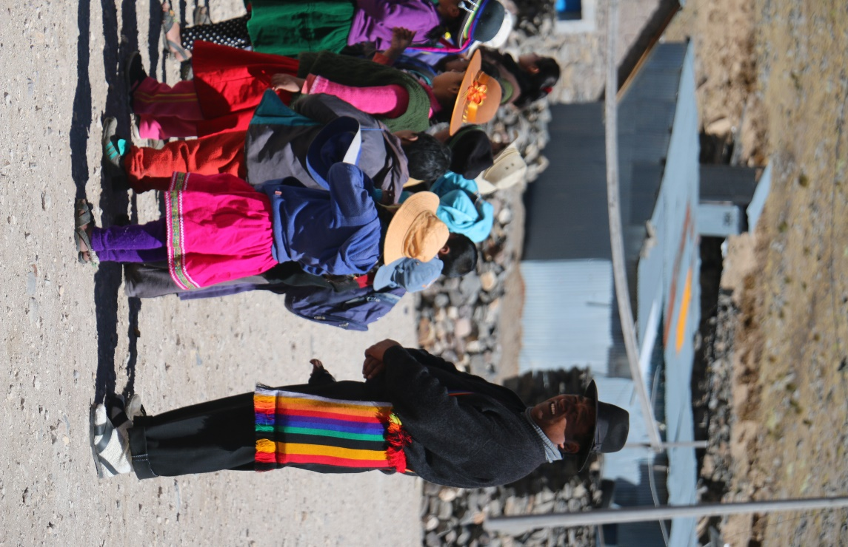

Students begin the school day as they line up outside in the court yard. A couple of weeks ago, this teacher worked with us as we taught the gospel with our Christmas program, complete with hot chocolate and sweet bread. We hope to continue visiting and helping these responsive people in this high-altitude area which is so spiritually and physically needy.

Challenges of remote high-altitude ministry

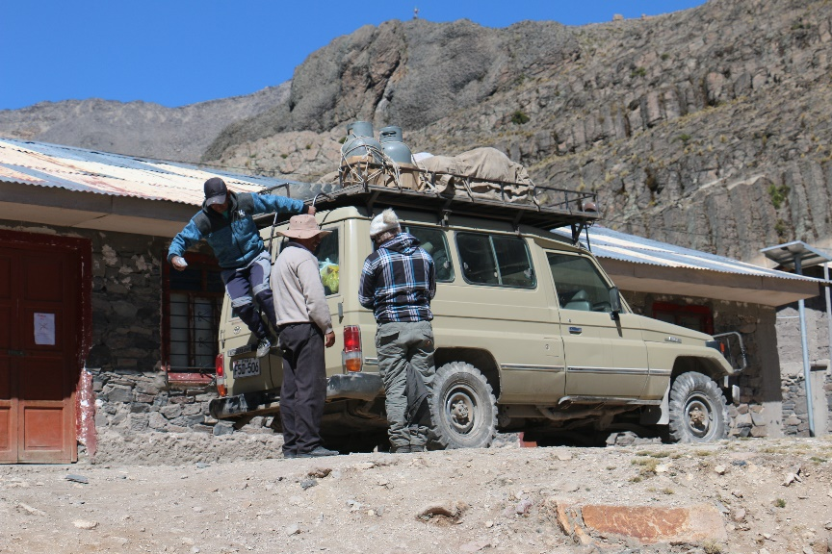

After about 8 hours’ drive from home and up over 16,000 feet elevation, our team of Quechua church planters arrive each month to teach the gospel to shepherd families and school children. We must
take adequate gear for freezing nights, all our food, camping kitchen, and all the tools and equipment to deal with whatever we might encounter (mechanical problems, getting stuck in streams or mud, etc.). Our current goal is to visit once a month, but during the summer rainy season, roads are often impassable. When the schools are open, the teachers allow us to sleep on the floor of the school rooms. Without reliable places to stay when we visit, we are hoping to build small portable cabins in some of the villages. These can be built from pre-fab kits we can buy in the city and then have trucked into the villages that have established “roads”. Then we can stay longer and minister from these cabin locations.

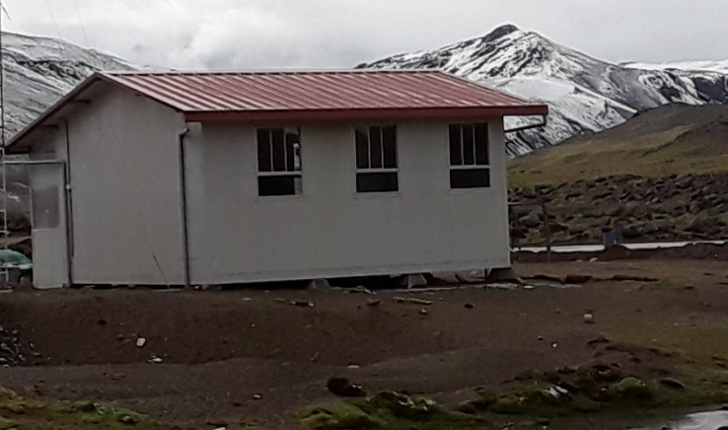 Example of a prefab/portable cabin available here in Peru.

Helping Flor (her name means flower)

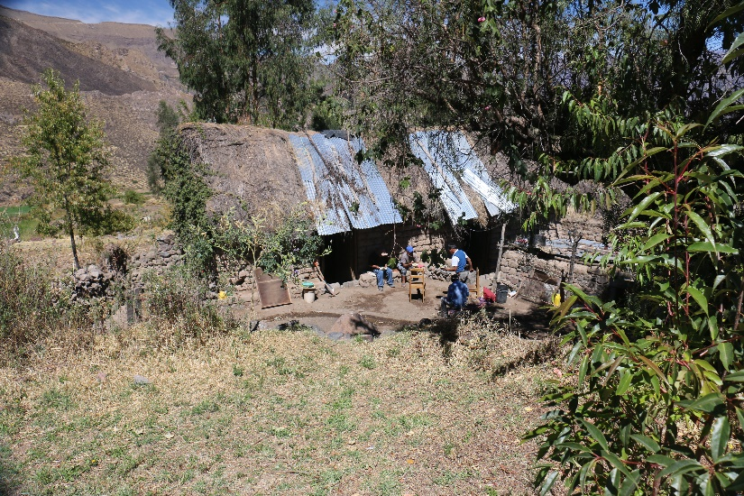

Flor is a sister in the Lord whose husband passed away several years ago. He was in the process of building them a better adobe house, but only was able to get a rough foundation in place. Since then, she has been living in a deteriorating hut left behind by extended family that no longer live in the village. The Lord enabled our team to finish building her house for her.

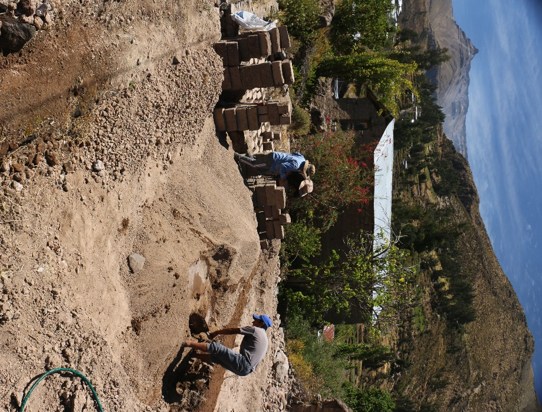
Without street access to her lot, heavy construction equipment is not possible
in this location

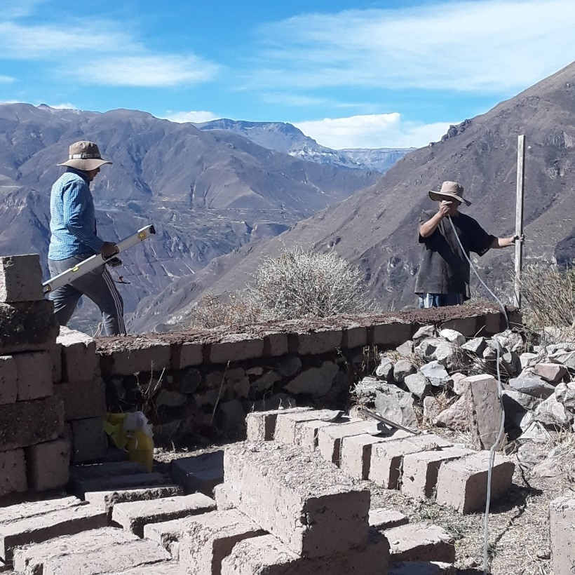
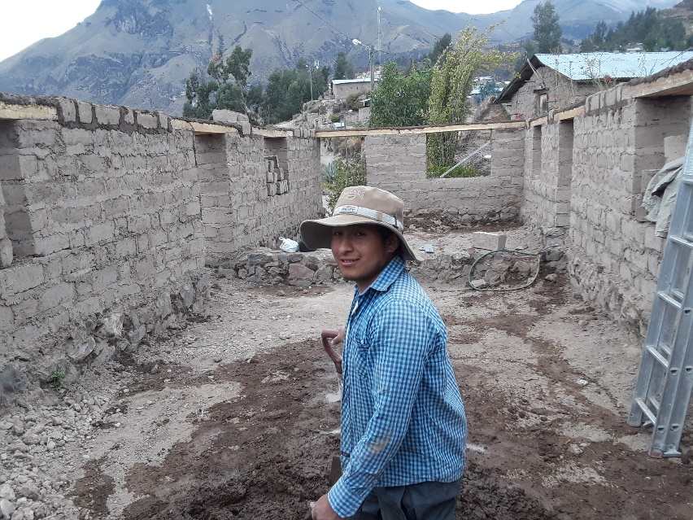
Jaime, a Bible student, learned how to do classic adobe construction.
Building the adobe house using old fashioned techniques including leveling with water in a clear hose.

Giving thanks for answered prayer

Safety:
-Our the team has experienced several dangerous situations and close calls on the mountain roads this year. We give thanks for no injuries or serious damage.
Health:
-Saturnina’s health has improved, however Santiago continues to suffer.
Leaders – calling and preparation
-Several faithful men have expressed more serious commitment toward preparing and serving in leadership within their village churches. Pray for God’s leading and guidance as they study and participate in discipleship.
-Jaime, Calip, Fredy, Faustino, Santos, Camilo, and Santiago continue to faithfully serve, learn, and help reach out to isolated villages.

Prayer requests:

-Please continue praying for the local Quechua church leaders and their spiritual growth and for new leaders to help reach out to the many isolated villages.
-Please pray for God to be glorified in the following ministries: radio, theological training, discipleship, biblical counseling & medical ministry.
- Please pray for the different spiritual challenges and temptations that Christians face here. Old customs of mysticism tempt some professing Christians to sometimes trust and participate in witchcraft and other dark beliefs that remain popular in the culture. Please pray for the clear and faithful teaching that our team must have as we admonish, correct, and call for repentance.

Thank you so much for “belaying” us by “Holding the Rope” in prayer and support. This all enables us to serve here in Peru for His glory. Your faith and love for Him and for us are a huge blessing & encouragement to us!

With our love,
Gina & Brad

bradley.shaw@sim.org gina.shaw@sim.org

How to support:

The Cotahuasi Ministry Project is SIM project #91252 and donations can be made through SIM by sending a check to: SIM Donor Care, P.O. Box 7900, Charlotte, NC 28241.

To give electronically please visit

www.quechuamissions.com

Face book page: Quechua Missions – Cotahuasi

