Dear Precious Friends in Christ,

Thank you so much for praying for the ministry here in Peru!

Since we last wrote, we have seen some difficult times here in Cotahuasi.

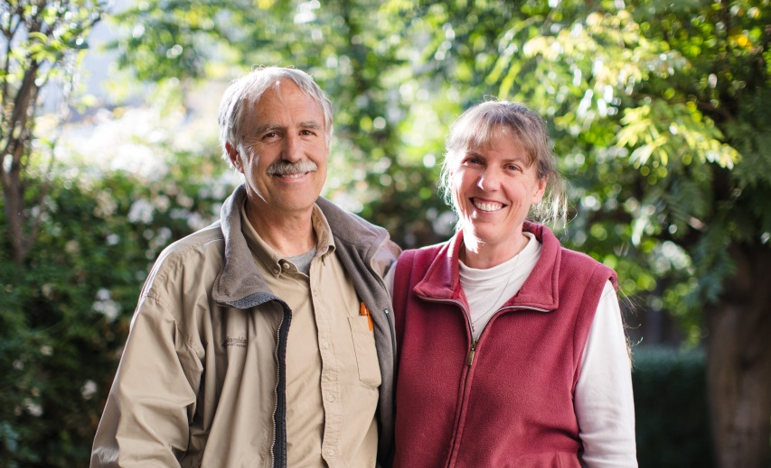

Our sister and friend so dear-to-us Rosa went to be with the Lord on May 9th. She was always encouraging us in her love for Him. She served alongside us in women’s & children’s ministry for many years, until the disease scleroderma made it too difficult for her to get around. She is greatly missed, but we rejoice and give thanks to our Lord for how He called her by His grace, gave her new life, and blessed so many here.

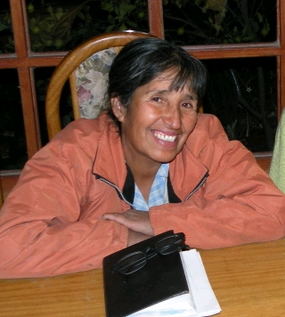

*Hermana Rosa*

Please pray for her family, her brother, Lorenzo, who faithfully continues working to plant churches in several villages here in the Cotahuasi Canyon. Also pray for her son, Hugo & her very elderly mom, Tarcila.

Santiago had been caring for his uncle over the years. He was hit by a car while walking along the road and passed away May 10th.

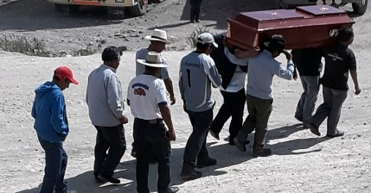

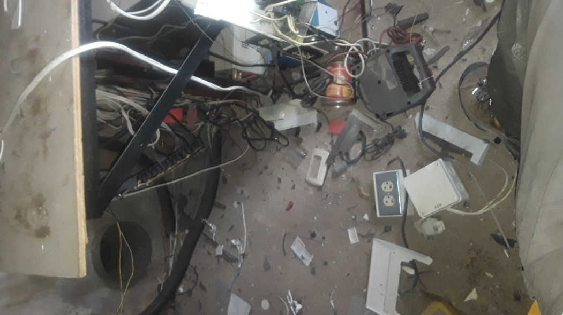

*Lightening at the Radio transmitter site*

*caused an explosion!*

In March, a storm passed through the area where our FM radio transmitter site is located. When we visited the site, we discovered severe lightning damage to our brand new electric power line. The remote-control system and two radios were also damaged. It will be a long and costly process to rebuild everything, but we are working to get back on the air as soon as possible. Please pray for wisdom, provision and for spiritual growth during this process. We are giving thanks for this, and that no one was in the building when it happened! Brad & Fredy are spending many hours up at the site (almost 14,000 feet elevation). We are trying to send the radios to the USA for repairs, but they are held up with difficult Peru customs processes.

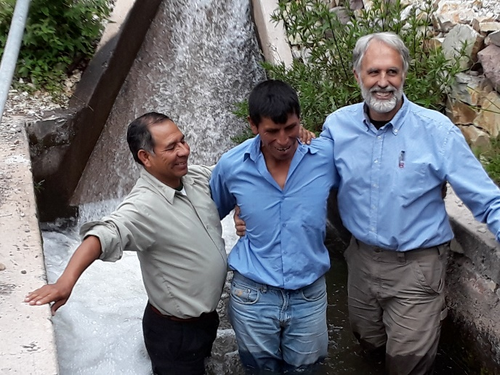

***Camilo – Praise the Lord for his spiritual growth! Santiago & Brad baptizing him in the canal near his farm.***

Prayer requests:

-Please pray for the local Quechua church leaders and their spiritual growth. Also pray for new leaders to help reach out to the many isolated villages throughout the Cotahuasi Canyon.

-Pray for God to be glorified in the following ministries: radio, theological training, discipleship, biblical counseling & medical.

[bradley.shaw@sim.org](mailto:bradley.shaw@sim.org) gina.shaw@sim.org

-Pray for safety, especially on these very dangerous mountain roads.

-Radio station – pray for the expansion of the reach of our broadcast listening area. Pray that we may get the station running soon.

-Please pray for Santiago & Saturnina’s health issues. Santiago needs hernia surgery but is hesitant because his wife Saturnina has never fully recovered from two surgeries she had a couple of years ago.

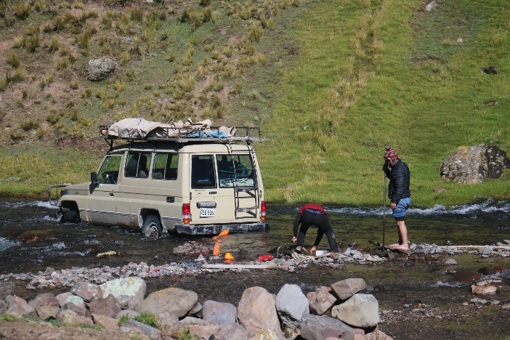

***Visiting remote villages can be challenging. This time we got stuck right in the middle of fording the river! We were on our way 20 hours later.***

Thank you so much for “belaying” us by “Holding the Rope” in prayer and continuing support. This all enables us to serve here in Peru for His glory. Your faith and love for Him and for us are a huge blessing & encouragement to us!

With our love,

Gina & Brad

**How to support:**

The Cotahuasi Ministry Project is SIM project #91252 and donations are made to SIM by sending a check to: SIM Donor Care, P.O. Box 7900, Charlotte, NC 28241.

To give electronically please visit

[www.quechuamissions.com](http://www.quechuamissions.com)

Face book page: Quechua Missions – Cotahuasi