Enter his gates with thanksgiving,
and his courts with praise!
Give thanks to him; bless his name!
For the LORD is good.
His steadfast love endures forever,
and his faithfulness to all
generations. Psalm 100:4-5

Greetings from Colorado. Yes, we are still waiting, but finally we can write with more certain plans to soon return “home” to Cotahuasi.
It has been a year of planning difficulties as our goals have repeatedly had to shift and adapt to new information and recommendations. We are thankful that the Lord has continued meeting more than our needs and allowed us to continue giving. We’ve been able to serve and minister through phone, texting, and video, continuing to meet for theology classes, morning devotions, administrative meetings, and biblical counseling.
For most of the year Peru has reported mortality rates much higher than any other country in the world, but the epidemic in Peru is subsiding now and vaccines are available.

Thank you for praying for us and the Quechua team in Peru. They continue to give thanks when we share with them how they have friends and a spiritual family caring for them through prayer and financial support. Gina and I also give thanks to the Lord for the blessing and privilege it is to participate with you and the Quechua team of church planters that God has called to serve.

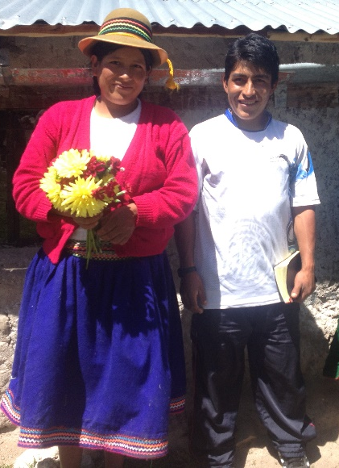
God’s grace amazes us as He continues drawing the ministry team closer to Him and each other. The challenges and many limitations of the “epidemic years” are providing different kinds of opportunities for growing in faith. It has been encouraging to observe and experience the love
and persistence in the ministry team as they Quechua believers living have suffered and in a remote village learned to trust the Lord more.

The epidemic in Peru has been a challenge, but we can give thanks and praise the Lord because He has been faithful to strengthen and mature many through suffering. Greater hunger for God and deeper trust in Him have been the good fruits of these challenging times and this continues to encourage us to look forward with an eternal perspective with expectation remembering God’s glorious and perfect plan. Even though we were not able to return sooner, the last year has been used of the Lord to grow us with greater trust in Him.

The Lord seems to have greater plans even for the Quechua people. Give thanks with us.

Answers to Prayers!
- The shortwave license has finally been granted and we received permission to use our first choice of frequency options, which engineers believe will give us the best coverage and signal quality!

- Sonset Solutions radio ministry continues to serve with us, engineering, assembling the transmitters and antennas, installing, and directing the maintenance of our radio stations.

- Seminary level theological education through TMAI Mexico has been successful in the first year of teaching and continues into the second. Local pastors and church planters are learning how to discern and faithfully minister the word to new believers and also prepare future pastors!

- Quechua Bible translators who have been trained by Wycliff Bible Translators have proposed a new 4-year translation project, coming to serve with our team in Cotahuasi to complete the entire Bible into the local Quechua dialect! Pray for God’s blessing, provision, workers, coordination, and faithfulness to the scriptures as they carefully work.

- Those on our team who have been sickened by Covid this year did recover and are doing well.

Questions we are often asked:
-What is “shortwave radio” ministry?
Shortwave public broadcasting has less fidelity than FM but reaches greater distances to many
more listeners.
Radio engineers estimate that our Bible programs will be heard by listeners living as far as 500 miles from our transmitter. This area is
home to millions of Quechua speakers. Shortwave is especially helpful in reaching rural listeners who have no cell coverage or economy to pay for expensive alternatives like satellite services. Many of these families have multiband receivers.

-What about those who have no shortwave radio receivers? How will they listen? We just have requested 2500 more solar powered hand-held radio receivers that could enable rural listeners to hear the Bible taught in the Quechua language.

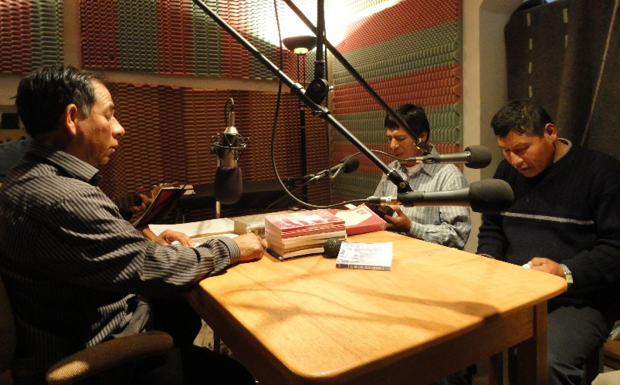
Radio bible teachers of “The Christian Path” radio station who are preparing Quechua language Bible programs.
Please pray for:
--The ministry of SonSet Solutions in Elkhart, IN who partner with us by providing radio expertise, engineering, training, and technical assistance. They design and build our transmitters, antennas, handheld receivers, and equipment for radio ministry. Pray for God’s provision for their ministry and needed specialized personnel.
--The discipleship, training, and theological education to equip Quechua leaders in different ministries and accepting greater responsibility. Pray for growth in humility, integrity, wisdom, perseverance, and trust in God and His word.
--Our travels from Colorado to Cotahuasi, scheduled for the last week in October.
--Importation of the FM transmitter into Peru. Customs processes can be costly and complicated in Peru.
-- As the team can once again visit villages, calling sinners to repentance, and discipling believers in great need, pray for encouragement and counsel during difficult times as the Holy Spirit’s transforming power works in people’s hearts.
--Inflation is worse now and greatly affecting the price of staples and other necessities: a liter of

cooking oil has doubled, propane cooking fuel up 30%, and noodles 50% more expensive. The local economy has returned to mostly subsistence farming and most of the ministry team are trying to find ways to grow more food. We are hoping to see their support increase to meet this need and see them free to focus on study, church planting, radio, and translation work.
--Pray for physical, spiritual, and emotional strength, endurance, and health to enable all those involved with ministries to obey the Lord and glorify Him throughout the Andes mountains of southern Peru.

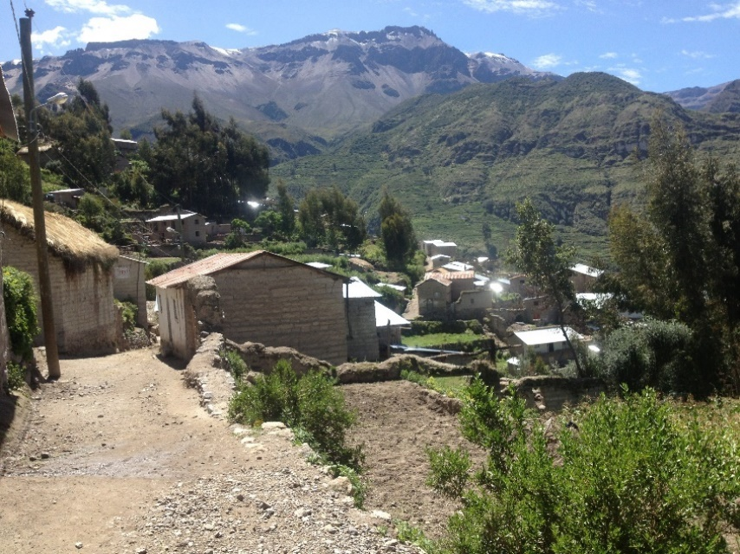
Quechua villages dot the landscape throughout the Andes mountains where the Holy Spirit is giving new life to people and giving them hunger to know their
One True Creator, Lord, and Savior Jesus Christ.

Thank you!

Your faith and love for Him, your prayers and support, are all huge blessings to us and the Quechua team in the Cotahuasi Canyon.

Please write us and let us know about your prayers and gifts at:
bradley.shaw@sim.org gina.shaw@sim.org

Face book page: Quechua Missions – Cotahuasi

How to support the ministry project:

Donations may be made through SIM by sending your check to:
SIM Donor Care, 14830 Choate Circle,
Charlotte, NC 28273

Please note the Cotahuasi Ministry Center Project account # is 91252 PE

To give electronically please follow the “giving” links at
www.quechuamissions.com

