Merry Christmas!

..The angel said to them, “Do not be afraid; for behold, I bring you good news of great joy which will be for all the people; for today in the city of David there has been born for you a Savior, who is Christ the Lord. Luke 2:10-11

We are so thankful to finally be back, visiting the villages and encouraging the faithful in their lives and ministries. There is new openness to the gospel.

Thank you for your prayers and concerns for us and the Quechua believers. The repaired radio transmitter made it through customs & once the dangers of seasonal lightning storms pass, it will be reinstalled. Together with you, we continue to bring this same good news of great joy to Quechua people in Southern Peru.

Seeing how the Lord kept His promises over so many years through history and in His perfect timing brought us a perfect Savior, causes believers throughout the world to joyfully and patiently wait for Christ’s certain return.

We continue to pray for you, asking our wonderful and loving Savior to grant you growing faith and love for Him and His precious people. God is always working to complete what He has begun in you, and we trust that you are seeing His great power working both in and through you. May He encourage you this season as we all worship, remember, and rest in knowing His love and care.

Please continue to pray for this next year’s ministry, hoping to see a shortwave transmitter installed and the Gospel reaching further out to many more Andes Mountain villages. Also please pray and consider supporting the Bible translation project scheduled to start in February.

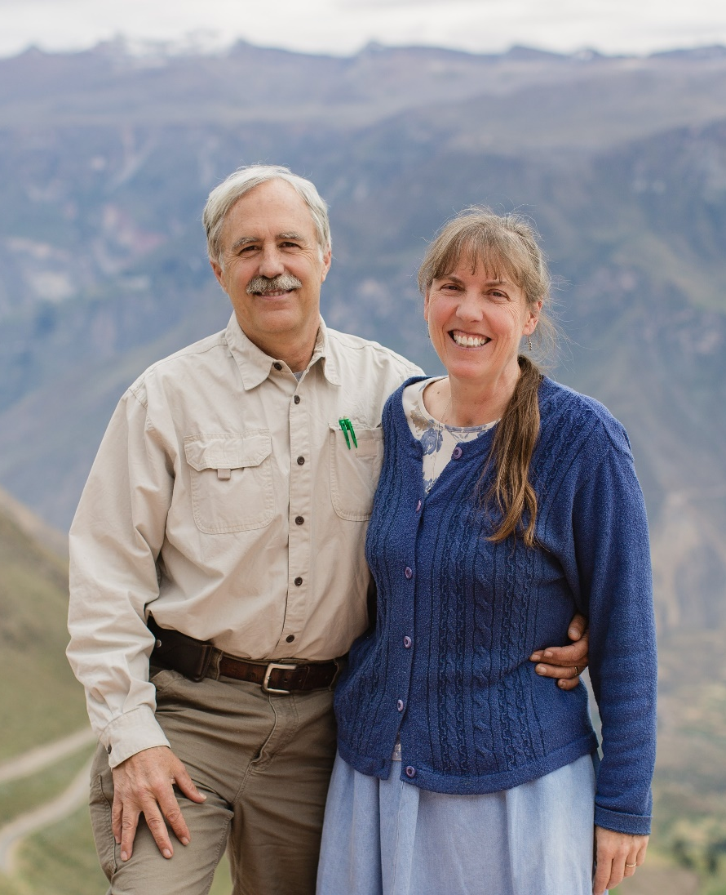

Thank you!

Please write and keep in touch:

bradley.shaw@sim.org gina.shaw@sim.org

Face book page: Quechua Missions – Cotahuasi

To support the ministry:

Donations may be made through SIM by
sending your check to:

SIM Donor Care, 14830 Choate Circle
Charlotte, NC 28273.

Please note the Cotahuasi Ministry Center Project
account # is 91252 PE

To give electronically please follow the “giving” links at
www.quechuamissions.com

